Lab Tasks
Problem 1:

Write a class named Employee that has the following member variables:
- name. A string that holds the employee’s name.
- idNumber. An int variable that holds the employee’s ID number.
- department. A string that holds the name of the department where the employee works.
- position. A string that holds the employee’s job title.

The class should have the following constructors:
- A default constructor that assigns empty strings ("") to the name, department, and position member variables, and 0 to the idNumber member variable.
- A constructor that accepts the following values as arguments and assigns them to the appropriate member variables: employee’s name, employee’s ID number, department, and position.
Write appropriate set and get methods to set and retrieve values in these member variable.
Now use these set methods with three different objects to set the class members with the values given below.

Create three objects and save above value is this members using set() and get() function. Now input data from user for all three objects.
Display the data for each employee on the console using get()and set()method. First display initialized data in objects and then after input from user display all data of three objects.
At the end when you exit your main() and know that your class object is now finish their work then write Destructor that shows a message “I am destructor ”.
Make class diagram of this problem.

Problem 2:
Write a class student with following data members and methods.
Private:
1. stdID //A string that hold the ID of student
2. stdName //A string that hold the name of student
3. dept //A string that hold the department name of student

Public:
1. Default Constructor initialize all member variables with null value
2. Overloaded Constructor1 (stdID= 12345, stdName = Ali Hassan)
3. Overloaded Constructor2 (stdID= 23456, std, Name = Sheraz Depp, dept = Computer Science)
4. Overloaded Constructor3 (stdName = Fahad abbas , dept = Computer Science)
5. inputData Input from user using this pointer for all members
6. displayData method that display data using this pointer
7. Destructor

Now in main function create three objects (obj1, obj2, obj3) and each call different constructors. Now create obj4 and initialize it with obj3 using copy constructor.
Now dynamically create 3 other objects and initialize them with any data of your choice. Show your results on console.
Explicitly call destructors for all local objects with proper message.
Problem 3:
• Define a class StudentRecord with data members
int rollNo
char* name
float gpa
• Write a default constructor to initialize the data members to the following values:
a. rollNo = 0
b. gpa = 0.0
c. Allocate dynamic memory for name (size 20)
d. Store "Unknown" in name
• Write overloaded constructor that will take rollNo, name and gpa as arguments and:
a. Allocate memory dynamically for name according to length of input
b. Copy the given name into allocated memory
• Write a copy constructor that will:
a. Allocate new memory for name
b. Copy the name from the source object
c. Copy rollNo and gpa
• Write a public function inputData to take student details from user and store them properly.
• Write a public function displayData to show student details.
• Create a dynamic array of StudentRecord of size 3.
• Assign memory at 0 index using default constructor.
• Assign memory at 1st index using overloaded constructor.
• Copy object at index 1 into index 2 using copy constructor.
• Modify the name of object at index 2 and display all objects to observe changes.
• Free memory by calling destructor.
• Show proper message for call of constructor, copy constructor and destructor.
Problem 4:
Create a class TicTacToe that will enable you to write a complete program to play the game of tic-tac-toe. The class contains as private data a 3-by-3 two-dimensional array of integers. The constructor should initialize the empty board to all zeros. Allow two human players. Wherever the first player moves, place a 1 in the specified square. Place a 2 wherever the second player moves. Each move must be to an empty square. After each move, determine whether the game has been won or is a draw.
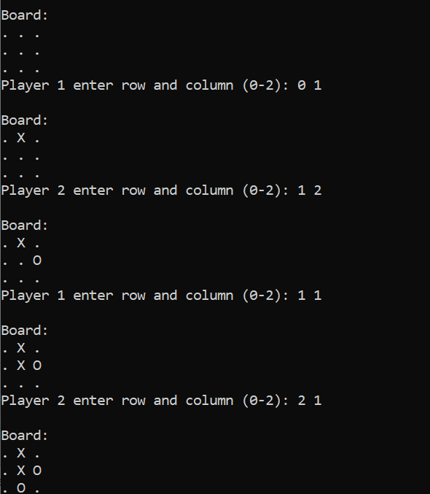
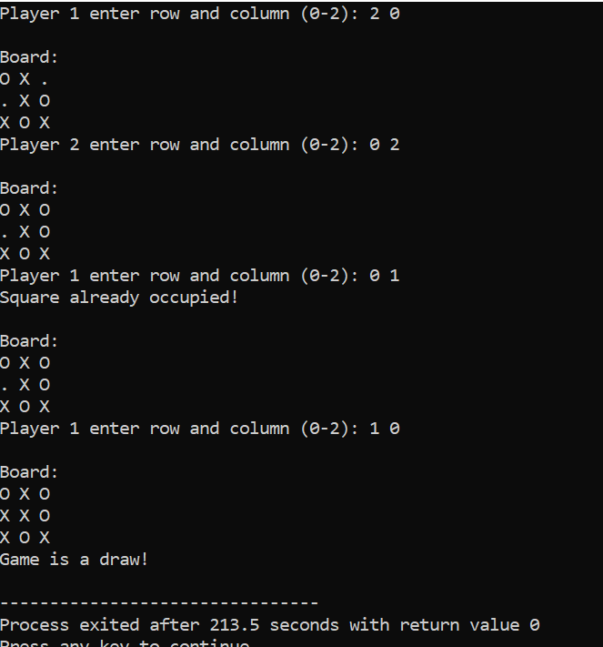
Proper code indentation will hold extra marks!

